Teachers: Arjhay Manalo Medrano and Zelvane Flores

Class: 4t ESO-C

School: Escola Anna Ravell

Name of the activity: Mucles toning and abdominals.

Introduction

-Good afternoon classmates, today we will be your teachers. We choise the activity of toning muscles and abdominals.

Equipment: Comfortable clothes.

Space: Gym.

Objectives: The objective are,

0-Starting activity

·Name: Streching muscles.

·Explanation: To make a sure activity, we need to stretch our body.

-Exercies 1: Arm rotation

-Exercies 2: doll rotation

-Exercies 3: Finger stretch

-Exercies 4: Head rotation

-Exercies 5: Stretch the arm.

·Time: 3 minutes.

·Materials: Mat
_______________________________________________________________

1r-First activity

·Activity: Toning

·Explanation: The first activity that you will do is the toning. We will do one of the exercise two times, 2 sets of 30sec.

-Exercies 1: Squads
-Exercies 2: Squads with a jump

-Exercies 3: Twisting knee plank
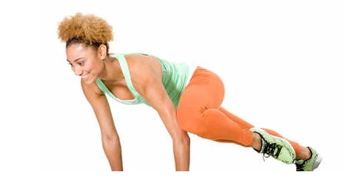
-Exercies 4: Biceps

-Exercies 5: triceps

-Exercies 6: push ups.

·Total time: 8 minutes.

·Materials: elastic bands for each student
_______________________________________________________________

2n-Second activity

·Activity: Abdominals.

·Explanation: The second activity is abdominals, take one mat for each of you.

-Exercies 1: Lower abdomen. 2 sets of 15

-Exercies 2: crun chest. One by one has to count 1 to 10 so If we are 25 student we will do 250 of crun chest.

-Exercies 3: single drop. 2 sets of 15.

-Exercies 4: bicicle. One by one has to count 1 to 10 so If we are 25 student we will do 250 of bicicle.

·Total time: 8 minutes

·Materials: Mat.

_______________________________________________________________

3r-Third activity

·Activity: Convination of toning and abdominals (intensive)

·Explanation: In the third exercise, we will make a conviantion of the toning and abdominals, but more intensive

-Exercies: 8 minuts of convination of toning and abdominals, we do 1 exercies of toning and then we do an abdominal.

·Music: I’ll bring the music in a pendrive.

·Total time: 8 minutes

·Materials: Mat and elastic bands

